Practical 8

**Start with HBase Shell**

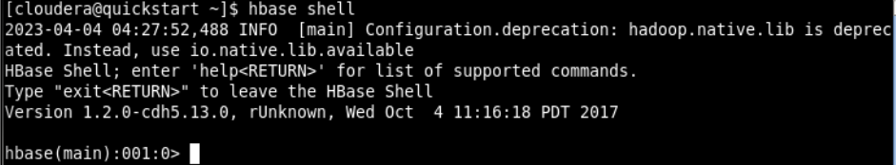

**Create a HBase table named ‘Student’ with column families StudID, StudName and StudAddress. Also cross check the creation and schema details of the table.**

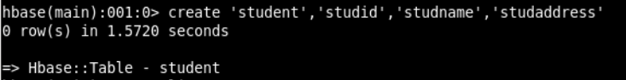

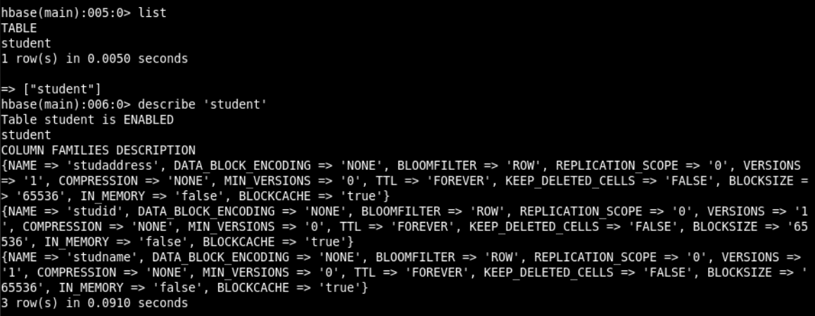

**Insert following data into the student table.**

**Syntax:** put 'Student','S01','StudName:FName','Amit' )

S01,Amit Prakash Vaze, Mulund

S02,Sumit Neeraj Kulkarni, Devi Dayal Road, Mulund W

S03,Alka Deepak Yadav, PK Road, Thane, Maharashtra

S04,Amit Neeraj Yadav, Goshala Road, Mulund W, Maharashtra

S05,Veena Pushkar Mhatre, JN Road, Thane W, Maharashtra

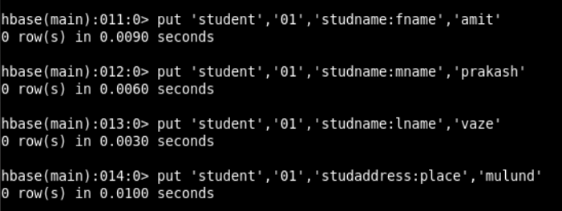

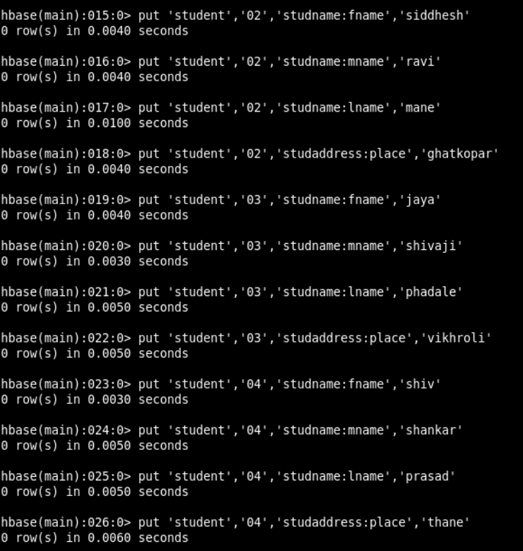

**Display all rows from the Student table. (scan command)**

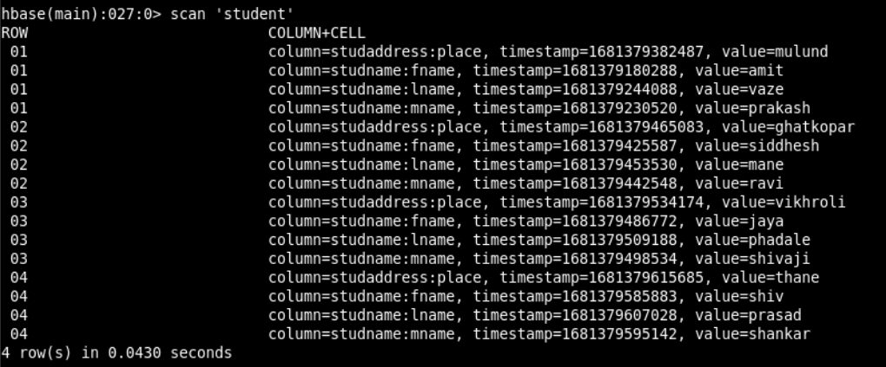

**Display address list of all students. (get command)**

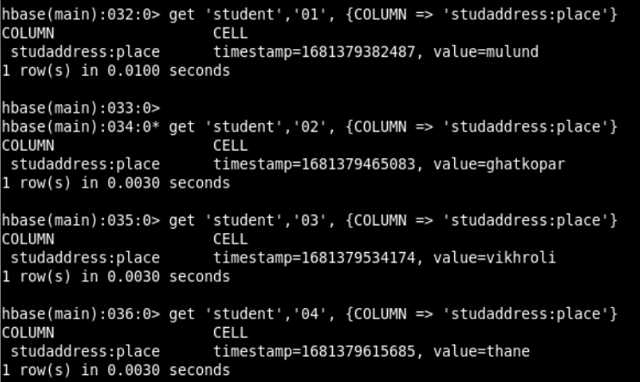

**Display list of students**.

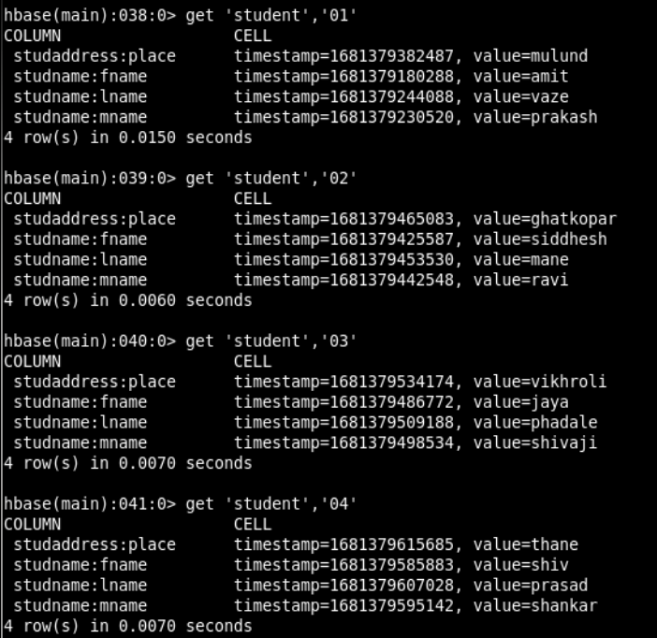

**To get a particular list**

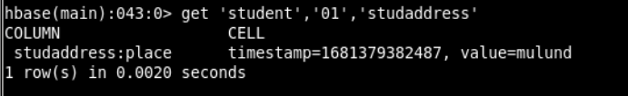

**Display total number of students.**

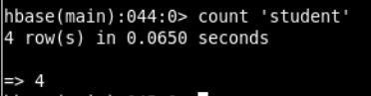

**Disable Student table and display the table schema using describe command.**

**Syntax:** >disable ‘Student’



**Check disabled status of the table using is-disabled command.**

**Syntax:** >is_disabled ‘Student’

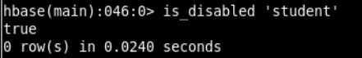

**Enable Student table and display the table schema.**

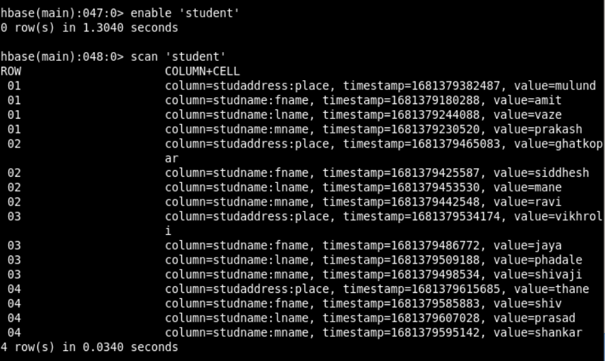

**Demonstrate the deletion of column values and a row.**

* **Deleting a specific cell**

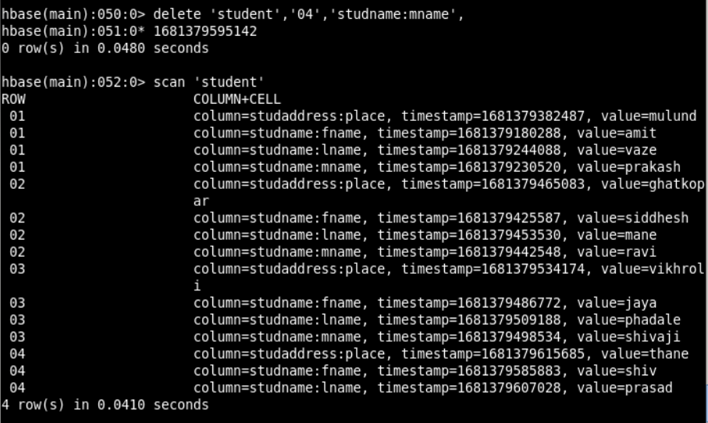

* **Deleting all cells**

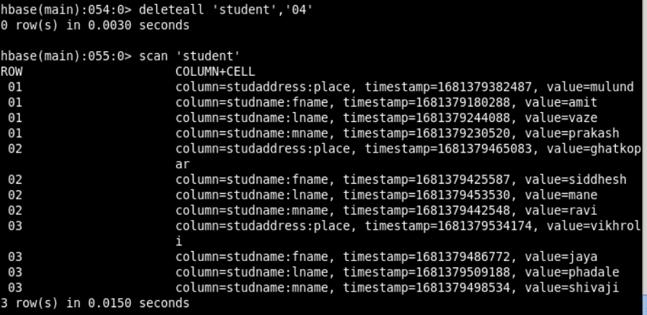

**Set the maximum number of cell changes to 5**.

**Syntax:** >alter ‘Student’, Name=’NewColFamily’, VERSIONS=>5

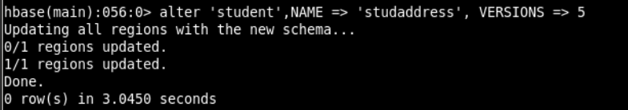

**Delete column family ‘Address’ from Student table.**

**Syntax:** >alter ‘Student’,‘delete’ => ‘Address’

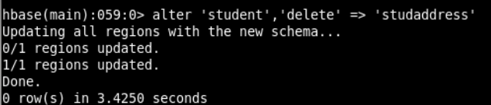

**Check the existence of the Student table.**

**Syntax:** >exists table_name

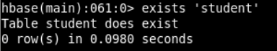

**Drop Table ‘Student’**

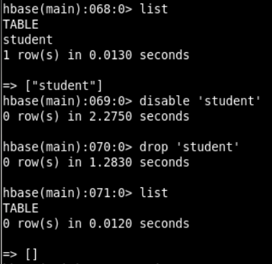

**Checking if the table exists**

